# **High Impact Skills Development Program**

# **AI & Data Science**

# **Arithmetic Operators ,Variables ,Python Input & Decision Making using Condition Statements**

# 

# **Lab 02**

**Introduction**

This lab is designed to develop the understanding of students with python input and arithmetic operations along with the use of variables and making use of the conditional statements.

**Objectives**

In this lab the students will learn the user input, arithmetic operations,use of variables and conditional statements in python.

**Tools/Software Requirement**

Jupyter Notebook ( Python )

#### **Arithmetic Operators**

The Python interpreter can be used to express the arithmetic operators in a very simple way as described below:

| **# For Addition**  print (1 + 1)  2 |
| --- |
| **# For Multiplication**  print (2 * 3)  6 |
| **# For Integer Division**  print( 17 / 10 ) 1 print (-17 / 10)  -2 |
| **#For Modulus**  print ( 27 % 10) 7 print (-27 % 10) 3 |

* For each of the following expressions, what value will the expression give? Verify your answers by typing the expressions into Python.

1. 9 - 3
2. 8 * 2.5
3. 9 / 2
4. 9 / -2
5. 9 // -2
6. 9 % 2
7. 9.0 % 2
8. 9 % 2.0
9. 9 % -2
10. -9 % 2
11. 9 / -2.0
12. 4 + 3 * 5
13. (4 + 3) * 5

#### **Variables**

| >>> length= 22.0 >>> width= 5.0 >>> Area= length *width >>> Area 110.0 |
| --- |

Variables are called variables because their values can vary as the program executes. We can assign a new value to a variable:

>>> degrees_celsius = 26.0  
>>> 9 / 5 * degrees_celsius + 32  
78.80000000000001

>>> degrees_celsius = 0.0  
>>> 9 / 5 * degrees_celsius + 32  
32.0

>>> difference = 20  
>>> double = 2 * difference  
>>> double  
40

* Create a variable x that stores an integer. Print out x, 2x, 3x, 4x, and 5x, each separated by three dashes, like below if x=7. (hint: use multiplication operator and print function)

7---14---21---28---35

**Taking Input in Python**

num = int(input("Enter a number: "))

print(num, " ", type(num))

floatNum = float(input("Enter a decimal number: "))

print(floatNum, " ", type(floatNum))

Output:

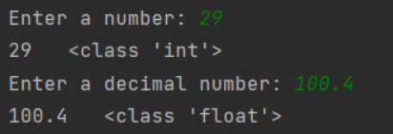

* Write a program that asks the user to enter two numbers, obtains the two numbers from the user and prints the sum, product, difference, quotient and remainder of the two numbers. Sample output is as following:

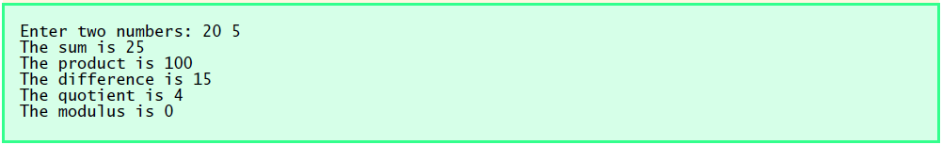

* Write a program that reads in the radius of a circle and prints the circle’s diameter, circumference and area. Use the constant value 3.14159 for π. Perform each of these calculations inside the print statement().

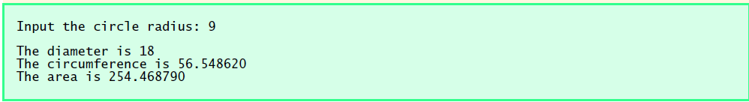

* Write a program that produces the following output using variables instead of hardcoding:

HHHHHH

HHHHH

HHH

HH

H

# 

# 

# 

# **Decision Making using Condition Statements and Logical Operators**

Basic relational operators used with **if…elif… else** statement

> greater than 5 > 4 is TRUE

< less than 4 < 5 is TRUE

>= greater than or equal 4 >= 4 is TRUE

<= less than or equal 3 <= 4 is TRUE

== equal to 5 == 5 is TRUE

!= not equal to 5 != 4 is TRUE

**‘and’**  Logical operator

| **Operand 1** | **Operand 2** | **Result** |
| --- | --- | --- |
| False | False | **False** |
| False | True | **False** |
| True | False | **False** |
| True | True | **True** |

**‘or’**  Logical operator

| **Operand 1** | **Operand 2** | **Result** |
| --- | --- | --- |
| False | False | **False** |
| False | True | **True** |
| True | False | **True** |
| True | True | **True** |

* Write a program that reads an integer and determines and prints whether it is odd or even.

* Write a program that inputs three different integers from the keyboard, and then prints the smallest and the largest of these numbers. **Use only the single-selection form of the *if statement*** that you learned in the class. The screen dialogue should appear as follows:

| Input three different integers: 13 27 14  Smallest is 13  Largest is 27 |
| --- |

#### **Lab Tasks**

**Arithmetic Operations**

* Which of the following expressions results in SyntaxErrors? Identify the syntax SyntaxErrors and type the reason of error along with the correct code by mentioning its sequence number.

1. 6 * -----------8
2. 8 = people
3. ((((4 ** 3))))
4. (-(-(-(-5))))
5. 4 += 7 / 2

* Using only the techniques you have learned so far, write a program that calculates the square and cube of the numbers from 0 to 10 and uses tabs to print the following table of values:

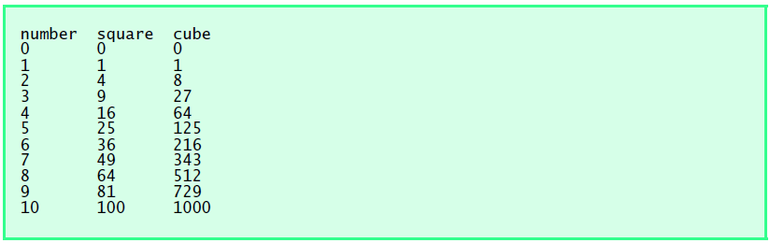

* Write a program that assigns values to two variables and then swap their values. *

**Variables and Python Input**

* Write a program that inputs one five-digit number, generates its reverse and displays the reverse on screen.(Hint: Make use of the arithmetic operators modulus (%) and floor (// )
* Using whatever we have learned so far, write a program that prints a box, an oval, an arrow and a diamond as follows:

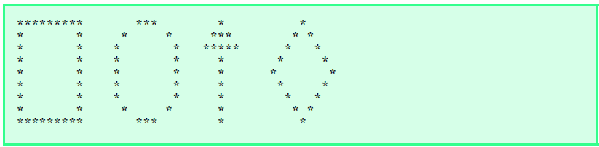

**Decision Making using Condition Statements**

* Write a program that reads three nonzero integers and determines and prints if they could be the sides of a right triangle. (Hint : use Pythagoras theorem you learned in mathematics during FSC or matric , try different combinations of the same integers )

| Enter three integers: 3 4 5  The three integers are the sides of a right triangle |
| --- |

| Enter three integers: 9 4 1  The three integers are not the sides of a right triangle |
| --- |

* Write a program to prompt for a score between 0.0 and 1.0. If the score is out of range, print an error message. If the score is between 0.0 and 1.0, print a grade using the following table:

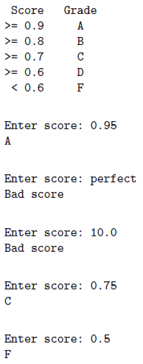

**Bonus:**

Write a program that asks the user for an hour between 1 and 12, asks them to enter am or pm, and asks them how many hours into the future they want to go. Print out what the hour will be that many hours into the future, printing am or pm as appropriate. An example is shown below.

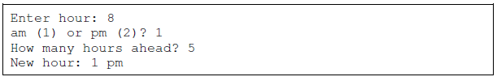

**Bonus:**

A palindrome is a number or a text phrase that reads the same backwards as forwards. For example, each of the following five-digit integers are palindromes: 12321, 55555, 45554 and 11611. Write a program that reads in a five-digit integer and determines whether or not it is a palindrome.

| Enter a five-digit number: 18181  18181 is a palindrome |
| --- |

| Enter a five-digit number: 16738  16738 is not a palindrome |
| --- |